Executive Summary
The AI Assistant enhances project management by leveraging AI capabilities. It provides intelligent search, content summarization, and contextual recommendations. This feature supports content interaction and boosts productivity and source recall.

Target Release | 5th July 2024
Epic | Past
Document Status | {READY}
Owner

Objective
The purpose of this feature is to allow users of the product to interact with their sources (and annotations, but separately) within a project -- for Haibrid, this aims to facilitate finding undiscovered use cases and assist business development.

Assumptions
- Users want to query multiple sources within a project rather than across projects
- The assistant will provide valuable and useful answers to the users.
- The users will want to query their annotations rather than the sources themselves.

Success metrics
Goal | Metric
How many users are using smart projects | - Number of Users
How often are they using the assistant | - Interaction Frequency

Requirements
- Please use British English for the assistant:
  - E.g. Summarise instead of Summarize
- “Enable Smart Project” functionality
  - When creating a project
  - When editing a project
- AI Assistant Window
  - Info on what “Enable Smart Project” is
  - Seeing the time the message was sent when hovering over a message in the assistant window
  - Copy action for the Assistant response
  - Regenerate action for the Assistant response
  - Smart Project - on the project card (in the “All Projects” page)
- Floating icon
- Notification count badge on the floating icon
- A switch between “Sources Only” and “Annotations Only”
- A status about the sources being scraped
- A “re-scrape” icon
- A welcome message
- A message telling the user what services the AI Assistant provides
- An indicator that the Assistant is generating an answer (Thinking…)
- A general error message when there is an issue while scraping the sources
- A message when the “re-scrape” icon is being clicked
- “Copy to clipboard” and “Regenerate” actions that can be performed with the Assistant’s answer
- An error message when there’s an issue generating a response
- A prompt to regenerate the answer when all sources have been scraped successfully
- Snackbars
  - Project Converted to Smart Project
  - Project Reverted to Standard Project
- Dialog Box
  - Project Conversion Confirmation
  - Project Reversion Confirmation
- Tooltips
  - …
- Assistant Icon Placement:
  - Only have the Assistant button in Project Page
  - On all project page, the cards should indicate that the project is a smart project…

User interaction and design
- When the user creates a project, there should be an option to “Enable Smart Project” in the “Create Project” popup, with a tooltip describing what a “Smart Project” is.
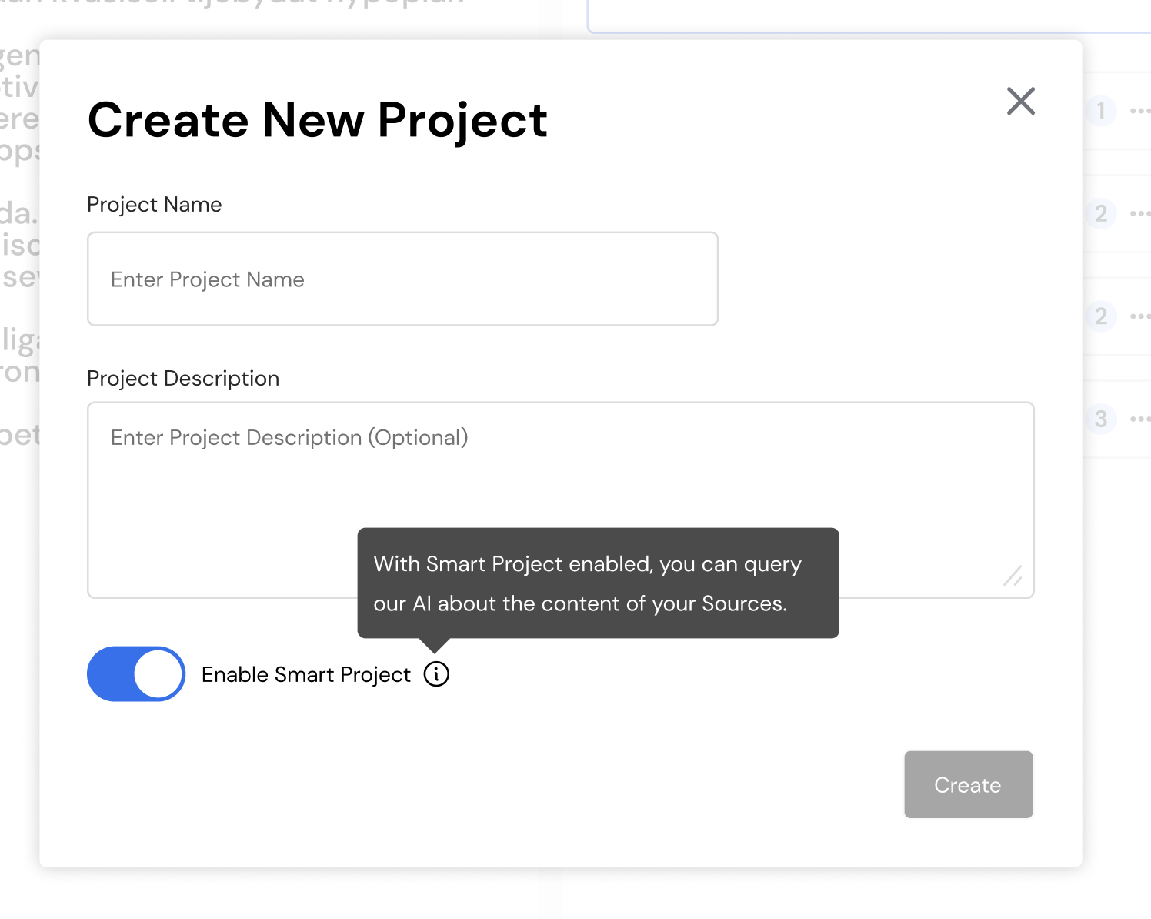

- After clicking on the “Create” button, the “Create Project” popup should close and the “Convert to Smart Project” popup should open, this dialog box exists for the user to confirm the conversion.
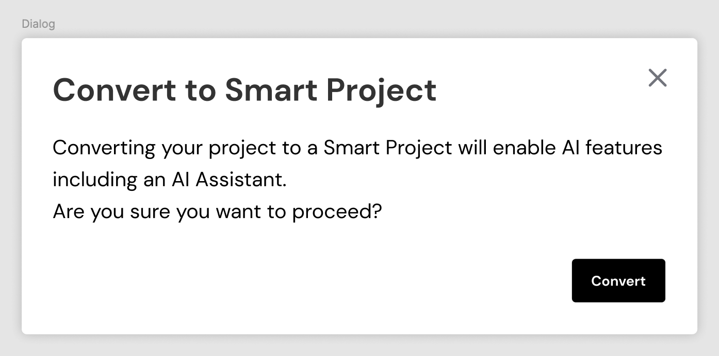

- Upon confirmation a snackbar should be shown.
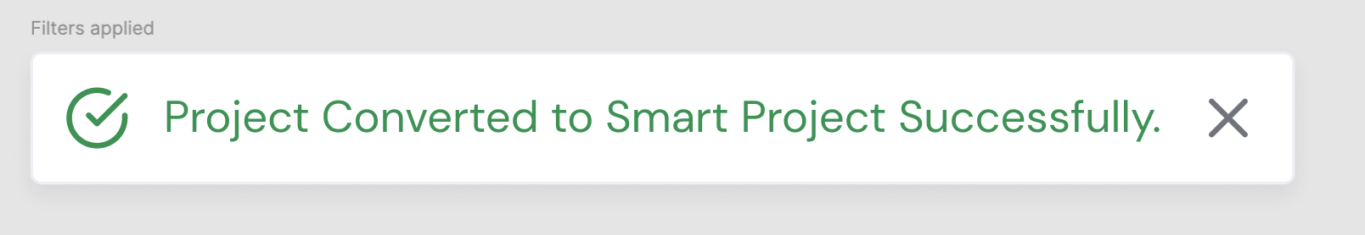

- The “Smart Project” conversion/reversion should also be available when editing already existing projects.
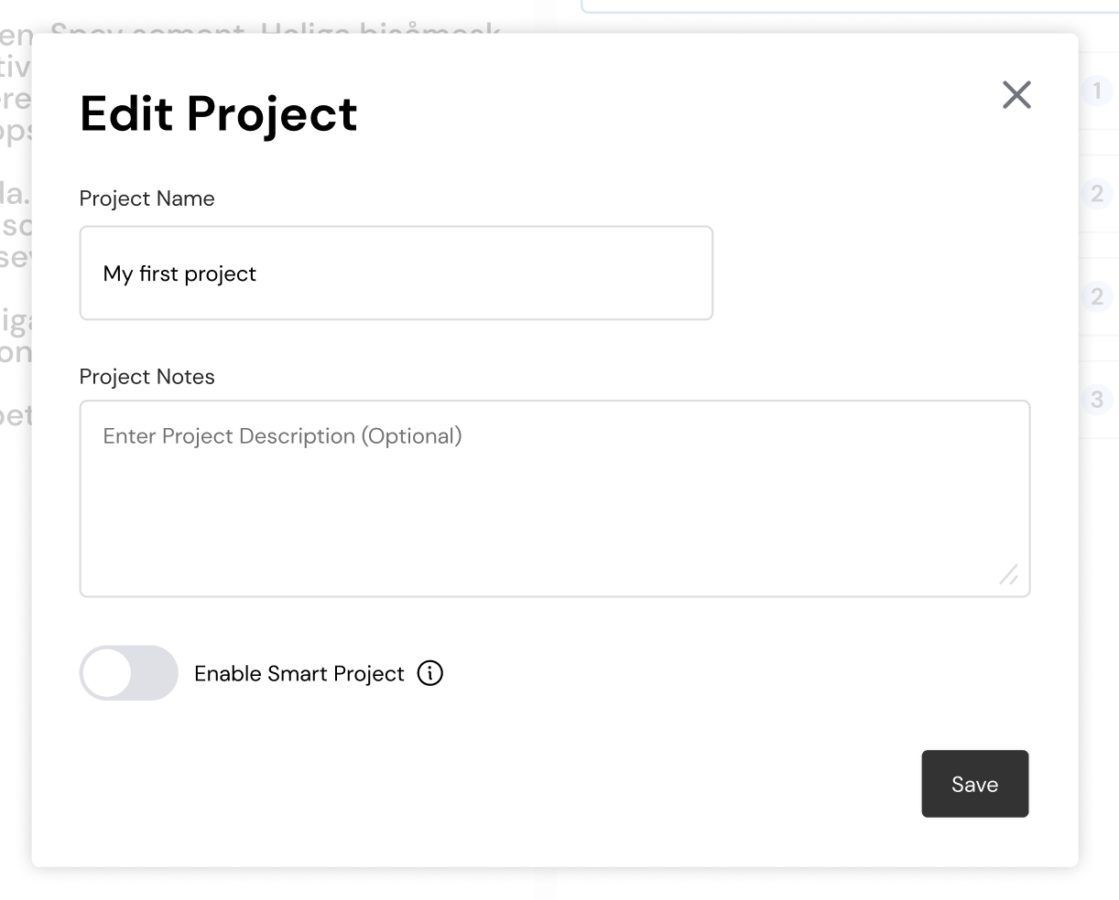
- When reverting a “Smart Project” to a “Standard Project”, there should be a dialog box for confirmation, followed by a snackbar if the action is confirmed.

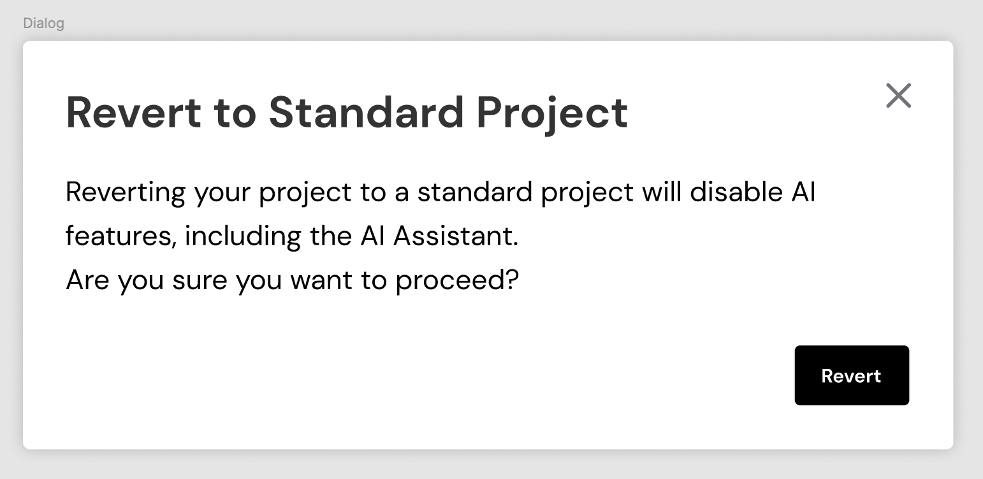
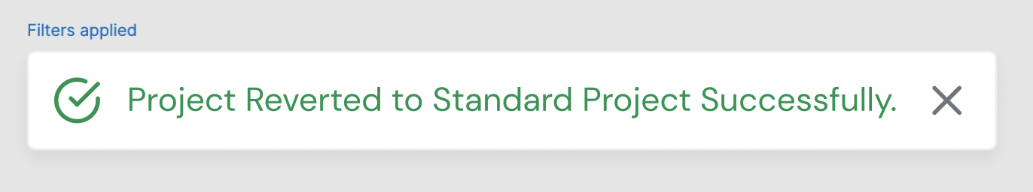

Open Questions
List all open questions for future discussion, reference or tracking

Out of Scope
- Chat History or Sessions
- File Upload
- Contextual menus: Provide users with relevant options and actions based on the current context, reducing cognitive load and clutter.
  - Dynamically adjust content based on the user's current context, such as the selected sources or project. They present relevant choices that are most likely to be useful or applicable at that moment
- Note Creation; Enable users to create new notes (annotations) or text for the document specifying the source material
- Feedback and Improvement: Feedback from users on their interactions with the chatbot to continuously improve
- Drag and Drop: Enables users to manipulate content by dragging annotations from sources into the documents.

